Odisha Power Transmission Corporation Ltd.
Bhubaneswar.



Agenda
for
141th Power System Operational Co-ordination Meeting

Date: 29.01.2020

Venue: Power Training Center, Chandaka, Bhubaneswar

Odisha Power Transmission Corporation Ltd. Bhubaneswar.

Agenda for 141th PSOC Meeting to be held on 29.01.2019 at OPTCL Power Training Center, Chandaka, Bhubaneswar

- Confirmation of the minutes of the 140th PSOC Meeting held on 24.12.2019
The minutes of meeting was circulated vide letter No. SGM (PS)-Pl-15/2019/4172⁽⁴⁹⁾ dated 27.12.2019 to all the members and also uploaded in the SLDC website. Members may offer their comments. If there are no comments, the minutes of the meeting may please be confirmed.
PART A
(List of items to be discussed for which the details are given in the subsequent parts)
B : Grid Performance for the month of December’2019
C.1: Review of implementation of PSDF approved projects of Eastern Region
C.2: Automatic Under Frequency Load Shedding (AUFLS) Scheme
C.3: Implementation of Automatic Generation Control in Eastern Region--ERLDC
C.4: Implementation of Automatic Demand Management Scheme.
C.5: Auxiliary power consumption by Powergrid Sub-stations--GRIDCO
C.6: Review of the PSS Tuning of Generators in Eastern Region --ERLDC
C.7: 220 kV Inter-connecting lines of OPTCL with 400/220 kV Bolangir (PG), Keonjhar & Pandiabil S/s
C.8: Bypassing arrangement of LILO of 400kV Lines at Angul
C.9: Update on status of telemetry
C.10: Mock Black start exercises in Eastern Region
C.11: Collection of modeling data from Renewable as well as conventional energy generators:
C.12: Monitoring of Next Six-Month New Element Integration in OCC and Its Update on Monthly Basis --ERLDC
C.13: Long term outage of transmission elements
C.14: Preparation of crisis management plan for Cyber Security in Power Sector in line with CERT-IN.
C.15: Submission of Thermal loading of transmission line and associated terminal equipment by ISTS Licensee.
C.16: Updated black start and restoration procedure of Eastern Region.

D.1: Non-compliance of drawal schedule by DISCOMs
D.2: Compliance of CEA Regulations for Grid Connectivity of Renewable Energy Sources.
D.3: Data communication from newly commissioned RE sources connected at 132 kV- SLDC
D.4: Despatch Scheduling for RE Generation.
D.5: Information regarding RE Sources for RPO Compliance monitoring.
D.6: Implementation of Automatic Meter Reading for OPTCL-Discom interface points.

E.1: Commissioning status of New Transmission elements.
E.2: HT metering at DISCOM interface points.-SLDC.
E.3: Major Events in the month of December’19
E.4: Important grid incidences during the month of December’19.
E.5: Outage of major transmission Elements during the month December’19. (above 10 hrs).
E.6: Prolonged outage of Transmission elements
E.7: Review of Outage Program of State Generators for the month of February’20
E.8: Generation Program for the month of February’20.
E.9: Anticipated power generation and demand for the month of February’20.
E.10: email id of SLDC for communication of message

F.1: Date and Venue of the next (142nd) PSOC meeting.

PART B: GRID PERFORMANCE
B. Review of Grid Performance for the month of December’19.
- Frequency:

Hourly frequency variation for the month of December’19.
Month | % of time frequency remained |  |  |  |  | Average
Month | <49.00 | 49.00-49.70 | 49.70-49.90 | 49.90-50.05 | >50.05
Oct’19 | 0.00 | 0.00 | 2.97 | 75.24 | 21.79 | 50.00
Nov’19 | 0.00 | 0.01 | 3.59 | 67.77 | 28.63 | 50.00
Dec’19 | 0.00 | 0.02 | 5.61 | 64.30 | 30.07 | 50.00

Maximum & Minimum frequency during the month of Nov’19 & Dec’19.
Month | Freq (Hz) | Date | Time
Nov’19 | Maximum –50.18 | 07.11.19 | 13:00 Hrs
Nov’19 | Minimum – 49.72 | 18.11.19 | 06:15 Hrs
Dec’19 | Maximum –50.18 | 16.12.19 | 03:00 Hrs
Dec’19 | Minimum – 49.74 | 09.12.19 | 14:15 Hrs
- Grid Demand up to the month of December’19
Month | Max. Consumption |  | Demand |  | Maximum Demand |  |  | Minimum Demand
Month | MU | Date | MU | Avg. (MW) | MW | Date | Time | MW | Date | Time
Apr’19 | 113.14 | 05.04.19 | 2786 | 3869 | 5151 | 04.04.19 | 20:00 | 2689 | 20.04.19 | 05:00
May’19 | 102.99 | 19.05.19 | 2638 | 3545 | 4635 | 18.05.19 | 24:00 | 1720 | 03.05.19 | 18:00
June’19 | 105.24 | 11.06.19 | 2653 | 3684 | 4790 | 11.06.19 | 23:00 | 2556 | 13.06.19 | 06:00
July’19 | 106.80 | 15.07.19 | 2744 | 3688 | 4899 | 15.07.19 | 21:00 | 2640 | 02.07.19 | 04:00
Aug’19 | 105.41 | 21.08.19 | 2924 | 3930 | 4901 | 16.08.19 | 21:00 | 3161 | 08.08.19 | 05:00
Sept’19 | 107.91 | 19.09.19 | 2780 | 3862 | 4969 | 18.09.19 | 20:00 | 2982 | 30.09.19 | 05:00
Oct’19 | 89.89 | 12.10.19 | 2519 | 3386 | 4385 | 20.10.19 | 19:00 | 2430 | 25.10.19 | 03:00
Nov’19 | 83.34 | 02.11.19 | 2166 | 3008 | 4086 | 02.11.19 | 19:00 | 2020 | 09.11.19 | 03:00
Dec’19 | 84.73 | 02.12.19 | 2232 | 3000 | 4206 | 02.12.19 | 19:00 | 2110 | 28.12.19 | 04:00
Dec’18 | 81.98 | 01.12.18 | 2188 | 2941 | 4038 | 01.12.18 | 19:00 | 1698 | 18.12.18 | 03:00
- Voltage Profile of 220 kV Buses in OPTCL system for the month of: November’19
SUBSTATION | MAX VOLTAGE (KV) | DATE | TIME | MIN VOLTAGE (KV) | DATE | TIME
Atri | 237.46 | 28-12-2019 | 02:45 | 220.03 | 19-12-2019 | 17:45
Balasore | 235.04 | 06-12-2019 | 03:30 | 224.59 | 11-12-2019 | 09:00
Barkote | 232.61 | 07-12-2019 | 03:30 | 226.90 | 19-12-2019 | 08:45
Bargarh | 228.75 | 30-12-2019 | 14:00 | 213.39 | 24-12-2019 | 17:15
Bhadrak | 232.67 | 06-12-2019 | 03:30 | 221.53 | 06-12-2019 | 17:45
Bhanjanagar | 239.20 | 28-12-2019 | 02:45 | 228.00 | 19-12-2019 | 17:45
Bidanasi | 239.66 | 16-12-2019 | 04:15 | 226.90 | 30-12-2019 | 11:30
Bolangir | 230.48 | 06-12-2019 | 03:15 | 212.35 | 24-12-2019 | 17:00
Budhipadar | 233.36 | 19-12-2019 | 13:45 | 215.06 | 30-12-2019 | 08:30
Chandaka | 236.83 | 28-12-2019 | 02:30 | 222.40 | 19-12-2019 | 17:45
Cuttack | 239.08 | 16-12-2019 | 04:15 | 220.95 | 02-12-2019 | 09:15
Duburi Old | 234.23 | 06-12-2019 | 03:30 | 226.15 | 19-12-2019 | 18:00
Duburi New | 242.66 | 06-12-2019 | 03:30 | 234.23 | 19-12-2019 | 18:00
Jayanagar | 240.87 | 28-12-2019 | 02:45 | 231.40 | 17-12-2019 | 07:30
Joda | 236.37 | 21-12-2019 | 14:00 | 226.03 | 28-12-2019 | 19:45
Katapalli | 229.79 | 05-12-2019 | 04:00 | 219.62 | 24-12-2019 | 17:15
Lapanga | 233.77 | 07-12-2019 | 01:45 | 227.88 | 24-12-2019 | 17:15
Laxmipur | 240.29 | 28-12-2019 | 02:45 | 230.02 | 04-12-2019 | 07:15
Mendhasal | 239.89 | 28-12-2019 | 02:30 | 225.28 | 19-12-2019 | 17:45
Meramundali | 229.61 | 02-12-2019 | 03:30 | 223.38 | 28-12-2019 | 18:30
Narendrapur | 242.72 | 07-12-2019 | 07:45 | 213.04 | 04-12-2019 | 07:15
Nayagarh | 238.45 | 28-12-2019 | 02:45 | 214.49 | 13-12-2019 | 18:45
Paradeep | 232.38 | 06-12-2019 | 03:30 | 219.97 | 26-12-2019 | 12:30
Tarkera | 229.67 | 19-12-2019 | 13:45 | 218.76 | 28-12-2019 | 09:30
Theruvali | 239.37 | 28-12-2019 | 02:45 | 227.42 | 04-12-2019 | 07:15
Rengali | 229.90 | 07-12-2019 | 03:30 | 224.76 | 19-12-2019 | 17:45

The maximum Voltage of 242.72 kV occurred at Narendrapur 220 kV bus., while Bolangir 220 kV bus has experienced the minimum Voltage of 212.35 kV. The 220 kV Voltage profile of Narendrapur and Bolangir ,and 400 kV Voltage profile of Mendhasal, Meramundali and New Duburi bus during the month of Dec’2019 are indicated in System performance presentation.
Members may discuss.
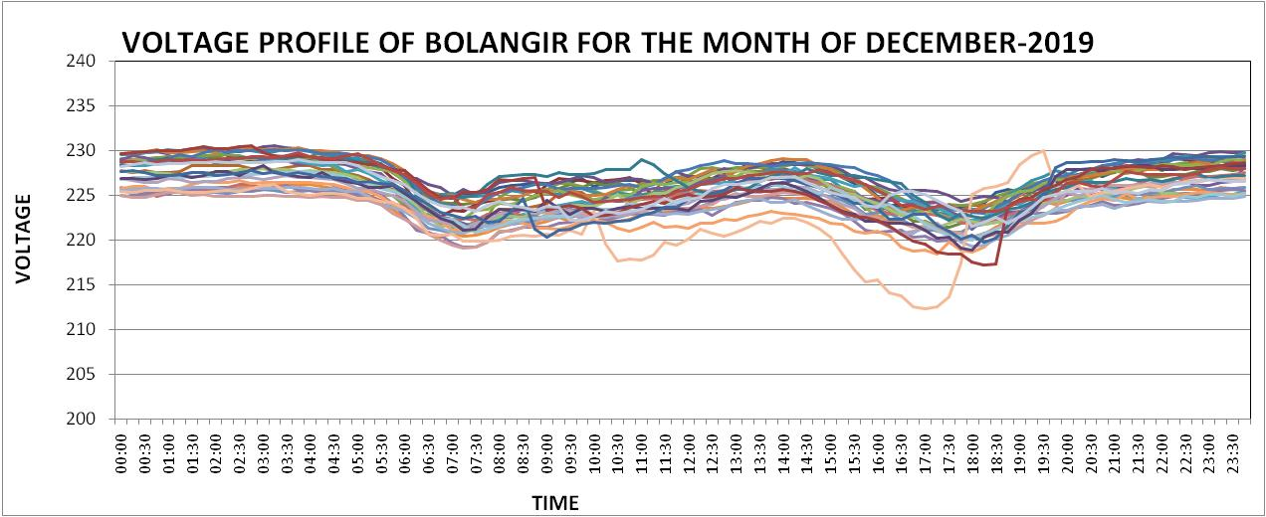
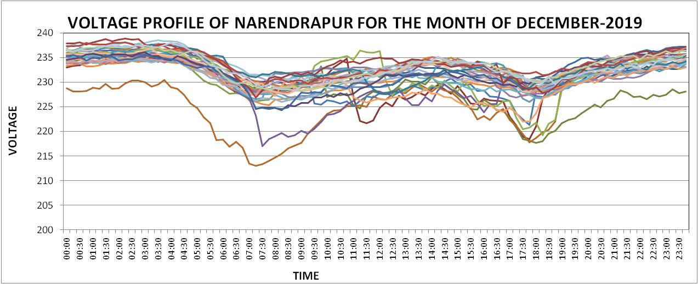
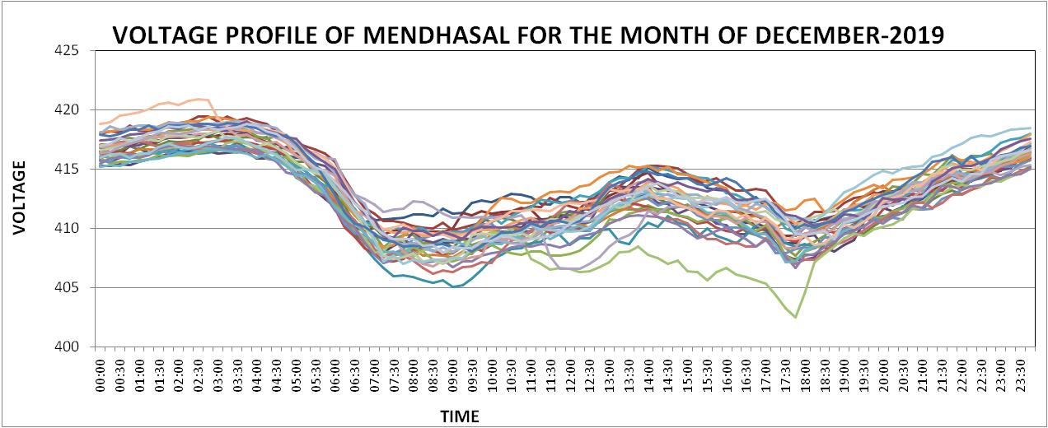
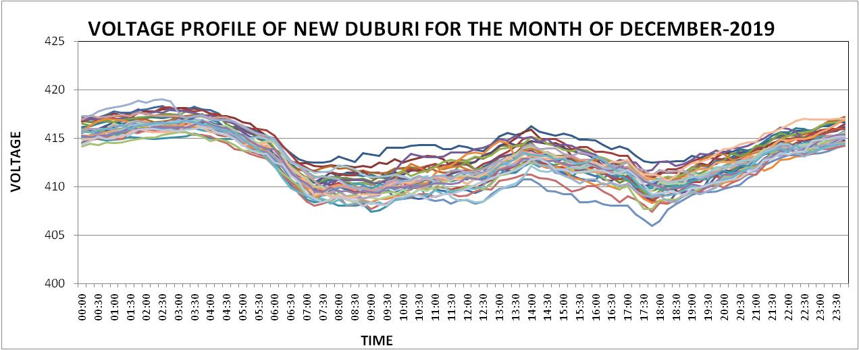
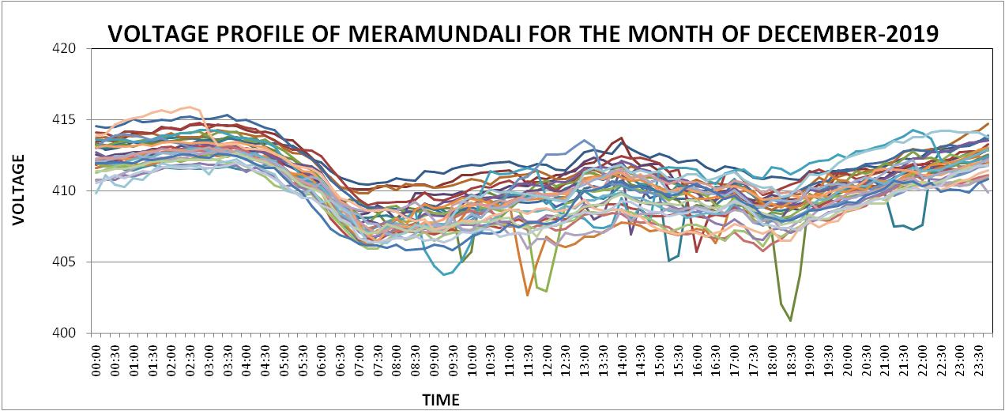

- Loading of 220/ 132 kV Auto at 220 kV S/Ss in OPTCL system for the month of DEC– 2019.
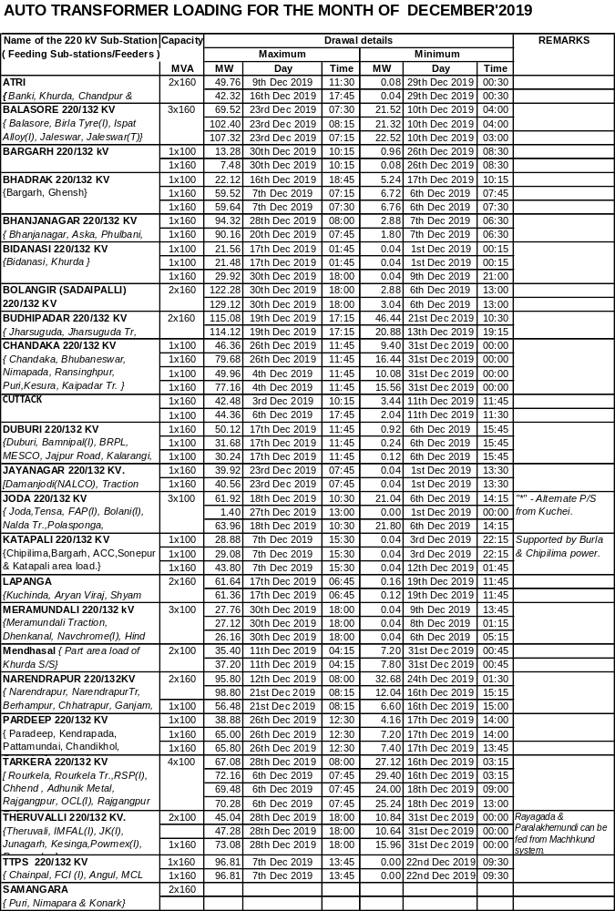

- DISCOM Drawal up to the month of December’19
Name of DISCOM | Month | Approved Energy Drawal Prorated for the month (MU) | Scheduled Energy (MU) | Actual Energy Drawal  ( MU) | Open Access Import Schedule  (MU) | Net Energy Drawal  ( MU) | Overdraw (MU)
Name of DISCOM | Month | 1 | 2 | 3 | 4 | 5=(3-4) | 6=(5-2)
CESU | Apr’19 | 798.00 | 760.542 | 857.404 | 18.345 | 839.059 | 78.517
CESU | May’19 | 824.97 | 664.438 | 689.035 | 16.166 | 672.869 | 8.431
CESU | June’19 | 798.00 | 758.651 | 793.853 | 17.431 | 776.422 | 17.771
CESU | July’19 | 824.97 | 778.505 | 798.994 | 15.847 | 783.147 | 4.642
CESU | Aug’19 | 824.97 | 745.852 | 785.057 | 14.196 | 770.861 | 25.009
CESU | Sept’19 | 798.00 | 766.486 | 755.33 | 15.336 | 739.994 | -26.492
CESU | Oct’19 | 824.97 | 739.392 | 740.459 | 16.154 | 724.305 | -15.087
CESU | Nov’19 | 798.00 | 595.388 | 610.682 | 17.688 | 592.994 | -2.394
CESU | Dec’19 | 824.97 | 546.908 | 559.218 | 13.749 | 545.469 | -1.439
WESCO | Apr’19 | 635.00 | 649.188 | 856.374 | 149.999 | 706.375 | 57.187
WESCO | May’19 | 656.42 | 703.036 | 841.28 | 100.32 | 740.96 | 37.924
WESCO | June’19 | 635.00 | 656.64 | 789.792 | 110.175 | 679.617 | 22.977
WESCO | July’19 | 656.42 | 670.083 | 835.876 | 143.639 | 692.237 | 22.154
WESCO | Aug’19 | 656.42 | 637.41 | 1043.79 | 423.111 | 620.682 | -16.728
WESCO | Sept’19 | 635.00 | 650.296 | 908.15 | 281.184 | 626.966 | -23.33
WESCO | Oct’19 | 656.42 | 605.866 | 678.503 | 71.157 | 607.346 | 1.48
WESCO | Nov’19 | 635.00 | 564.911 | 695.851 | 165.109 | 530.742 | -34.169
WESCO | Dec’19 | 656.42 | 569.338 | 796.044 | 224.353 | 571.691 | 2.353
NESCO | Apr’19 | 517.00 | 478.905 | 600.692 | 99.608 | 501.084 | 22.179
NESCO | May’19 | 534.45 | 508.934 | 629.852 | 89.858 | 539.994 | 31.06
NESCO | June’19 | 517.00 | 490.244 | 607.403 | 105.15 | 502.253 | 12.009
NESCO | July’19 | 534.45 | 532.112 | 660.208 | 131.831 | 528.377 | -3.735
NESCO | Aug’19 | 534.45 | 493.554 | 627.779 | 128.157 | 499.622 | 6.068
NESCO | Sept’19 | 517.00 | 451.669 | 557.042 | 99.737 | 457.305 | 5.636
NESCO | Oct’19 | 534.45 | 446.652 | 556.344 | 105.563 | 450.781 | 4.129
NESCO | Nov’19 | 517.00 | 372.351 | 482.904 | 103.582 | 379.322 | 6.971
NESCO | Dec’19 | 534.45 | 367.461 | 512.244 | 123.942 | 388.302 | 20.841
SOUTHCO | Apr’19 | 331.00 | 303.576 | 334.361 | 0 | 334.361 | 30.785
SOUTHCO | May’19 | 342.19 | 320.055 | 336.003 | 0 | 336.003 | 15.048
SOUTHCO | June’19 | 331.00 | 318.393 | 324.819 | 0.116 | 324.703 | 6.31
SOUTHCO | July’19 | 342.19 | 315.891 | 305.83 | 0.061 | 305.769 | -10.122
SOUTHCO | Aug’19 | 342.19 | 291.711 | 296.609 | 0 | 296.609 | 4.898
SOUTHCO | Sept’19 | 331.00 | 298.482 | 290.17 | 0.007 | 290.163 | -8.319
SOUTHCO | Oct’19 | 342.19 | 285.153 | 283.453 | 0.263 | 283.19 | -1.963
SOUTHCO | Nov’19 | 331.00 | 262.522 | 254.704 | 0 | 254.704 | -7.818
SOUTHCO | Dec’19 | 342.19 | 243.367 | 251.773 | 0 | 251.773 | 8.406

The figures are as per EBC data. Energy drawal by SOUTHCO are excluding of energy consumed by NALCO at Damanjodi and IMFA at Theruvali.

Members may please discuss.

- Energy Generation / Import up to the month of December’19
Figures in MU
Month | Thermal  (TTPS+IbTPS) | OHPC  & MKD | CGP Support | IPP Inj. | RE | ISGS | Total
April’19 | 588.681 | 538.473 | 308.480 | 263.019 | 29.852 | 1057.035 | 2785.540
May’19 | 608.185 | 571.561 | 290.845 | 203.850 | 46.247 | 916.949 | 2637.637
June’19 | 581.856 | 414.962 | 329.321 | 212.683 | 47.362 | 1066.419 | 2652.603
July’19 | 566.902 | 407.505 | 363.839 | 198.433 | 46.030 | 1171.210 | 2753.919
Aug’19 | 359.551 | 836.840 | 345.534 | 56.723 | 46.535 | 1278.578 | 2923.761
Sept’19 | 828.709 | 808.759 | 328.938 | 75.013 | 44.608 | 694.453 | 2780.479
Oct’19 | 931.846 | 815.124 | 201.462 | 170.221 | 43.395 | 357.406 | 2519.453
Nov’19 | 1002.867 | 462.376 | 284.32 | 174.39 | 39.004 | 202.254 | 2165.561
Dec’19 | 871.252 | 388.621 | 392.156 | 173.107 | 40.443 | 366.245 | 2231.824
Total | 6339.849 | 5244.221 | 2844.896 | 1527.437 | 383.473 | 7110.545 | 23450.774

- Drawal of Machhakund Power
The drawal of Machhakund power up to the month of December’19 are as detailed:
Month | Total Generation |  | Odisha Drawl |  | AP Drawl
Month | MU | Avg (MW) | MU | Avg (MW) | MU | Avg (MW)
Apr’19 | 53.168 | 73.84 | 24.896 | 34.58 | 26.401 |  | 36.67
May’19 | 60.577 | 81.42 | 26.811 | 36.04 | 31.821 |  | 42.77
June’19 | 52.203 | 72.50 | 22.395 | 31.10 | 30.840 |  | 42.84
July’19 | 59.779 | 80.35 | 26.579 | 35.73 | 31.116 |  | 41.82
Aug’19 | 53.318 | 71.66 | 24.773 | 33.30 | 27.139 |  | 36.48
Sept’19 | 52.348 | 72.71 | 23.869 | 33.15 | 26.276 |  | 36.494
Oct’19 | 51.532 | 69.26 | 23.229 | 31.22 | 25.936 |  | 34.860
Nov’19 | 55.359 | 76.89 | 26.311 | 36.54 | 26.995 |  | 37.493
Dec’19 | 60.914 | 81.87 | 28.374 | 38.14 | 30.091 |  | 40.44
Total | 499.198 |  | 227.237 |  | 256.615
In the 136th PSOC meeting Southco stated that Dasmantpur feeder in expected to be charged today i.e. on 21.08.2019.
Sr.GM (O&M), Zone –I suggested to explore the following link lines for providing adequate matching load in Machhakund system.
- Connecting Patangi S/S or Proposed Lamtaput S/S with Podagada S/S through 132 kV link.
- Providing Sunabeda S/S area load in Machhakund system
- Modification of Jayanagar S/S to accommodate Jayanagar load

In the 137th PSOC meeting, SOUTHCO stated that 33 kV Dasmantpur feeder did not stand after charging. Insulators are being changed by the contractor. Sr. GM (Const) stated that 132 kV Patangi-Podagada line is under construction and expected by March’2020. He also suggested to utilize 132 kV NALCO-Sunabeda line to feed Sunabeda area load from Machhakund system by bus splitting.

In the 139th PSOC meeting SOUTHCO stated that insulator changing of Dasmantpur feeder is under progress. It was suggested that GRIDCO may convene a meeting with PMU for early restoration of the feeder, so that, more matching load can be provided in Machhakund system. SLDC may write to PMU to ascertain the status of feeders at Podagada S/S.

In the 140th PSOC meeting SOUTHCO stated that about 10 Nos of span have left for insulator changing. CGM (O&M) suggested to connect 33kV Medical feeder may with Podagada S/S for increase load at Machhakund system. Patangi –Podagada 132 kV connectivity is expected by March’19, by which, more load can be kept in Machhakund system. Further Rly. is requesting to change the connectivity of Rayagada Traction feeder from Rayagada to Theruvali S/S. GRIDCO has agreed to convene a meeting with PMU to discuss the issue.

GRIDCO / O&M/SLDC/SOUTHCO may deliberate.

- Under Frequency Relay operation in OPTCL System during the month of December’19.
Since, the frequency had never gone beyond the lowest setting of UFR, there was no UF Relay operation occurred during the month of December’19.

- Status of Open Access applications up to the month of December’2019

The status of different types of Open Access applications received and disposed by SLDC is as tabled.
Sl. No | Month | No of Applications received |  |  |  |  | No of Applications Disposed |  |  |  |  | No of App. Rejected | MU
Sl. No | Month | Intra-State | Inter-State |  |  | Total | Intra-State | Inter-State |  |  | Total | No of App. Rejected | MU
Sl. No | Month | Intra-State | Bilateral |  | PX | Total | Intra-State | Bilateral |  | PX | Total | No of App. Rejected | MU
Sl. No | Month | Intra-State | ST | MT/  LT | PX | Total | Intra-State | ST | MT/  LT
1 | April’19 | 48 | 100 | 0 | 24 | 172 | 48 | 100 | 0 | 24 | 172 | 0 | 522.98
2 | May’19 | 21 | 92 | 0 | 29 | 142 | 21 | 92 | 0 | 29 | 142 | 0 | 487.30
3 | June’19 | 49 | 106 | 0 | 32 | 187 | 49 | 106 | 0 | 32 | 187 | 0 | 641.01
4 | July’19 | 94 | 60 | 0 | 28 | 182 | 94 | 60 | 0 | 28 | 182 | 0 | 726.36
5 | Aug’19 | 114 | 132 | 0 | 38 | 284 | 110 | 132 | 0 | 38 | 284 | 4 | 904.48
6 | Sept’19 | 66 | 122 | 0 | 58 | 246 | 66 | 122 | 0 | 58 | 246 | 1 | 576.64
7 | Oct’19 | 42 | 43 | 0 | 34 | 119 | 42 | 43 | 0 | 34 | 119 | 0 | 360.33
8 | Nov’19 | 66 | 50 | 0 | 35 | 151 | 66 | 50 | 0 | 35 | 151 | 0 | 593.07
9 | Dec’19 | 53 | 59 | 0 | 29 | 141 | 53 | 59 | 0 | 29 | 141 | 0 | 661.84
 | Total | 511 | 721 | 0 | 273 | 1505 | 511 | 721 | 0 | 273 | 1505 | 5 | 4812.17

PART C – Issues discussed in the 165th OCC meeting of ERPC on 22.01.2020

C.1: Review of implementation of PSDF approved projects of Eastern Region.

NLDC (POSOCO) being the Nodal Agency for PSDF schemes, is carrying out PSDF Secretariat function under directions of MoP. Recently NLDC is directed by MoP to disburse the PSDF sanctioned funds as early as possible as its non-utilization is being viewed seriously by MoP on various fora.

All the constituents are requested to furnish/update the status of their respective project in every OCC and also requested to submit requisition for disbursement to NLDC at the earliest by 1st February 2020, so that amount may be released by 31st March 2020.

The latest status as updated by OPTCL / OHPC is as given below:
Sl No | Name of  Constituent | Name of Project | Date of approval from PSDF | Target Date of Completion | PSDF grant  Approved (in Rs.) | Amount  Drawn till date (in Rs.) | Status as updated in  129th meeting
4 | OPTCL | Renovation & Up-gradation of protection and control systems of Sub-stations in the State of Odisha in order to rectify protection related deficiencies. | 11.05.15 | 31.03.20 | 162.5 Cr.  Total expenditure may not exceed Rs. 68 Cr. | 38.09Cr. Received Rs. 8.00 Cr on 28.03.19 | Work almost completed.
7 |  | Implementation of OPGW based reliable communication at 132kV and above substations | 15.11.2017 |  | 51.22 Cr | 2.56 Cr received as 10 % DPR. Claimed for 20 %. | Order placed. Expected by Nov’19. Inspection under process.
13 | OHPC | Renovation & up-gradation of protection & control system of 4 nos. OHPC sub-stations |  | U.Kolab-  March 19  Balimela-  Feb 2019  U.Indravati-Jan 19  Burla-Nov18  Chiplima  Dec 2018 | 22.35 Cr. | 2.674 Cr | Placed work order for Balimela. PO for other units amounting Rs. 12.79 Crs placed. Order under process.
Projects under process of approval:
 | OPTCL | Installation of 125 MVAR Bus Reactor along with construction of associated bay each at 400kV Grid S/S of Mendhasal, Meramundali & New Duburi for VAR control & stabilisation of system voltage | 27-07-18 |  | 31.94 Cr  Ested. Cost. Approved amount 30.26 Cr. Grant amount 27.23 Cr. | Rs.2.72 Cr received as 10% of DPR. Retendering under process. | Agreement sent to NLDC for signature. The L-1 bidding proce ia higher than the estimated cost..Expected by end of Dec’19.
Projects recently submitted:
 | OPTCL | Implementation of Automatic Demand Management System (ADMS) in SLDC, Odisha | 22-12-17 Date of submission |  | 3.26 Cr Estt cost. 2.93 Cr recommended by Appraisal committee. |  | CERC approval received. Tendering under process.
 | OPTCL | Protection up gradation and installation of SAS for seven numbers of 220/132/33kV Grid substations (Balasore, Bidanasi, Budhipadar, Katapalli, Narendrapur, New-Bolangir & Paradeep). | 12.03.2018 Date of submission |  | 41.1 Cr  Estt cost | 10% of DPR to be asked. | Project approved. Tender to be opened on 16th Dec’19. Agreement will be sent to NLDC after signature by Govt.
CGM (Const)/CGM (O&M) / OHPC may deliberate

C.2: Automatic Under Frequency Load Shedding (AUFLS) Scheme

In the 2nd meeting of NPC held on 16th July 2013, the following AUFLS scheme with 4 stages of frequency viz. 49.2 Hz, 49.0 Hz, 48.8 Hz & 48.6 Hz had been decided to implement in all the regions:

AUFLS | Frequency(Hz) | Load Relief in MW
AUFLS | Frequency(Hz) | NR | WR | SR | ER | NER | Total
Stage –I | 49.4 | 2160 | 2060 | 2350 | 820 | 100 | 7490
Stage –I | 49.2 | 2170 | 2070 | 2360 | 830 | 100 | 7530
Stage –I | 49.0 | 2190 | 2080 | 2390 | 830 | 100 | 7590
Stage –I | 48.8 | 2200 | 2100 | 2400 | 840 | 100 | 7640
Total |  | 8720 | 8310 | 9500 | 3320 | 400 | 30250
The scheme had been implemented throughout the country.

xxxxxxxx

In 9th NPC meeting held on 22.11.2019, it was decided to implement the AUFLS scheme with 4 stages and raising the frequency by 0.2 Hz viz. 49.4, 49.2, 49.0 & 48.8 Hz by keeping the quantum for AUFLS same as decided in 2nd NPC Meeting. It was also decided that a committee with all RPCs and NLDC would study and review the required quantum for each slab of AUFLS and submit a report to NPC. Minutes of the meeting are awaited.

The total load quantum for ER constituents is given below:
Control Area | Stage –I (49.4 Hz) (MW) | Stage –II (49.2 Hz) (MW) | Stage–III (49.0Hz) (MW) | Stage–IV (48.8Hz) (MW) | Total Relief by Control Area
Bihar | 98 | 99 | 99 | 101 | 397
Jharkhand | 61 | 62 | 61 | 62 | 246
DVC | 134 | 135.5 | 136 | 137 | 542.5
Odisha | 181.5 | 183.5 | 184 | 186 | 735
WB & CESC | 345.5 | 350 | 350 | 354 | 1399.5
Total | 820 | 830 | 830 | 840 | 3320

In 42nd TCC, all the constituents were advised to implement the revised AUFLS scheme as per the NPC decision within a month and submit a report to ERPC Secretariat and ERLDC.

TCC decided to review the implementation status in the next OCC Meeting.

In the 140th OCC meeting OPTCL stated that action has already been initiated to revise the UFR setting and feeder configuration.
O&M may update.

C.3: Implementation of Automatic Generation Control in Eastern Region--ERLDC
In compliance to CERC’s direction in order dated 06/12/2017 in petition no 79/RC/2017, AGC was commissioned in NTPC Barh on 01st August 2019 and operationalized since 23rd August, 2019.

Vide order dated 28th August 2019, CERC in Petition No.: 319/RC/2018 directed that all the ISGS stations whose tariff is determined or adopted by CERC shall be AGC-enabled and the ancillary services including secondary control through AGC be implemented as per the following direction:

I. All thermal ISGS stations with installed capacity of 200 MW and above and all hydro stations having capacity exceeding 25 MW excluding the Run-of-River Hydro Projects irrespective of size of the generating station and whose tariff is determined or adopted by CERC are directed to install equipment at the unit control rooms for transferring the required data for AGC as per the requirement to be notified by NLDC. NLDC shall notify the said requirements within one month of this order.

II. All such ISGS stations whose tariff is determined or adopted by CERC shall have communication from the nearest wide band node to the RTU in the unit control room.
xxxxxxxxx
IX. All new thermal ISGS stations with installed capacity of 200 MW and above and hydro stations having capacity exceeding 25 MW excluding the Run-of-River Hydro Projects irrespective of size of the generating station and whose tariff is determined or adopted by CERC shall mandatorily have the capability to provide AGC support.

In the 162nd OCC, it was clarified that AGC signal for intra-state generating stations would be generated by the concerned SLDC and the relevant communication path is to be established between SLDC to plant. For ISGS stations, the AGC signal would be sent from NLDC.

All concerned plants may please ensure taking necessary action for arranging the communication (through redundant and alternate paths) from the existing nearest wideband communication node to their unit control rooms through two fibre optic cables, in coordination with CTU. It may please be noted that all the ISGS stations whose tariff is determined by or adopted by CERC should be AGC-enabled before 28th February 2020, as per order of CERC.

OCC suggested that even though the total capacity is tied up with GRIDCO, depending the area control error during low/high frequency scenario, the generation can be increased / decreased up to 5% by sending AGC signal from SLDC. Member Secretary advised OPGC to submit their action plan within 7 days for implementation of AGC. Further OPGC may depute their officers to visit Barh NTPC station to study the mechanism they have adopted for AGC. SLDC may interact with NLDC in this regard.
Summary status of implementation of AGC

Unit#3 of OPGC | SLDC, Odisha and OPGC agreed to submit their plan by 1st week of Nov19.
In 42nd TCC, DVC intimated that AGC shall be implemented in unit 7 and 8 of Mejia as per the given schedule by 31st July 2020.

Odisha informed that SLDC and OPGC will sit together and finalise the scheme.

WBPDCL informed that they have already collected offer from Siemens for implementation of AGC and they are awaiting the concurrence from SLDC.

SLDC, WB informed that they are not in a position to implement AGC unless a clear direction is given by WBERC. Further, implementation of intra state DSM is a prerequisite for implementation of AGC in the state.

It was decided to request CERC to include this as an issue in the Agenda for discussion in the meeting of Forum of Regulators.

In the 140th PSOC meeting, it was decided to convene the meeting by SLDC with OPGC & O&M after finalization of the commercial issue.

SLDC/ OPGC may deliberate
C.4: Implementation of Automatic Demand Management Scheme
The latest status along with proposed logic as follows:
Sl. No | State /Utility | Logic for ADMS operation | Implementation status/target | Proposed logic (if different from under implementation logic
1 | Odisha | 1. System Frequency < 49.9 Hz  2. Odisha over-drawl > 150 MW  3. DISCOM over-drawl > (40 MW) | 10 Months  Sent for PSDF approval | Logic 2 and 3 is AND or OR, in case it is AND then ADMS may not operate when DISCOMs are in schedule but GRIDCO is over drawing due to less generation at State embedded generators.
In the 138th PSOC meeting SLDC stated that technical sanction has been done and forwarded to CPC for tendering.

It is learnt that tender will be floated by end of January’20
SLDC may deliberate.
C.5: Auxiliary power consumption by Powergrid Substations--GRIDCO
As per decision of Special meeting on this issue held at ERPC on 10.07.2018, drawal of auxiliary power through tertiary winding by Powergrid substations shall be treated as drawal by Powergrid from the DISCOM (s). For this, Powergrid shall approach the concerned DISCOM(s) and shall complete all the necessary formalities to become a consumer of the concerned DISCOM.
Powergrid is not becoming the consumer of DISCOM Utility as a result of which, GRIDCO/DISCOM(s) are unable to realize the revenue from Powergrid, whereas GRIDCO is paying for the said quantum of energy consumed by Powergrid since October, 2017.

The above issue was deliberated in 163rd OCC meeting held at Puri, Odisha on 15.11.2019, wherein Powergrid informed that DISCOMS (WESCO & CESU) are asking POWERGRID to pay for the Security Deposit, Maximum Demand charges and Meter rent etc. Powergrid stressed that, as the entire infrastructure for auxiliary power consumption through tertiary was provided by POWERGRID only and not by the DISCOMs, these charges are not applicable in this case. Powergrid further informed that they are not paying such charges for other states. DISCOMs informed that they are requesting for the payment of Security Deposit, Maximum Demand charges and Meter rent etc. in line with the OERC Regulations.

DISCOMs informed that they would not have any objection in case OERC allows any exemption to Powergrid in this matter.

After detailed deliberation, OCC advised Powergrid to file a petition before OERC for exemption of Security Deposit, Maximum Demand charges and Meter rent etc.

WESCO vide letter dated 16/11.2019/ 12.12.2019 requested GRIDCO to withdraw the quantum of energy billed to DISCOM towards auxiliary power consumption of Powergrid through its tertiary winding of ICT till finalization of Petition to be filed by PGCIL before OERC.

In view of the above, GRIDCO suggest that DISCOMs need to raise the bill to Powergrid on the quantum of energy billed to DISCOMs by GRIDCO on monthly basis till finalization of the issue of Security deposit, Maximum demand charges & Meter rent. A copy of the bill should be marked to GRIDCO every month.
In the 140th PSOC meeting GRIDCO stated that POWERGRID will file the Petition before the OERC by next OCC meeting
All DISCOMS/ POWERGRID may deliberate.

C.6: Review of the PSS Tuning of Generators in Eastern Region --ERLDC
On 31st January 2019, PSS Tuning Meeting was held at ERPC. All generating utilities were advised to complete the PSS tuning of their plant at earliest for improvement of damping in the grid during transients. In addition, the tuning reports have also to be submitted to ERLDC/ERPC for their validation.
In line with this ERLDC has communicated to following utilities in view of the recent oscillation observed during various events:
Generating Power Plant | Remarks | Status of Action Plan to be informed to OCC
All Units of OPGC and OHPC, | PSS are tuned long back and in many units PSS have not been tuned but are in service. | OPGC Units-February;2020.
GMR | Was done in 2013 and retuning is required with change in the network at Angul. | During overhauling in Dec’2020
Sterlite 4 X 600 MW | Due to network changes. | Planned in the month of June 2020.
OHPC/ GMR / OPGC / Vedanta may deliberate.
C.7: 220 kV Inter-connecting lines of OPTCL with 400/220 kV Bolangir(PG), Keonjhar & Pandiabil S/s
PGCIL has already commissioned the 2 X 315MVA 400/220kV Bolangir S/s by LILOing of 400 kV Meramandali-Jeypore S/C line and 400/220 kV Keonjhar S/s with an objective of supplying power from ER grid to its adjoining areas in Odisha.

In 140th PSOC meeting the status has been updated as follows:
Sl. | Name of the transmission line | Completion schedule
1. | 2 X 315MVA 400/220kV Bolangir S/s
a. | LILO of one circuit of Sadeipalli-Kesinga 220 kV D/C line at Bolangir (PG) S/S. | Construction of 220 kV Sadeipali- Kesinga line has started. 220 kV Sadeipali-Bolangir (PG) portion of the line is expected by March’20.
2. | 400/220 kV Keonjhar S/S.
a. | Keonjhar (PG)-Keonjhar (220/33 kV) & 220 kV D/C line | 220 kV S.C line and Keonjhar S/S (220/33 kV), 2x20 MVA charged on 31.12.2018. 2nd ckt; charged on 03.08.2019.
b. | Keonjhar (PG)-Turumunga (220/132 kV) & 220 kV D/C Line. | By 2021. Order placed.
3. | 400/220 kV Pandiabil Grid S/s
a. | Pratapsasan(OPTCL)-Pandiabil (PG) 220 kV D/C | June’2020

C.GM (Cont) / CGM (Telecom) may update.

C.8: Bypassing arrangement of LILO of 400kV Lines at Angul
LILO of Meramundali-Bolangir/Jeypore 400 kV S/C line and LILO of one Ckt of Talcher-Meramundali 400 kV D/C line has been done at Angul 765/400kV Sub-station. The bypass arrangement for these circuits is under implementation at Angul by Powergrid.

In 158th OCC, Powergrid informed that bypass arrangement would be completed by August 2019. OPTCL informed that 2nd circuit of 400 kV Meramundali-Mendhasal line would be commissioned
by 1st week of August 2019.
OPTCL informed that 2nd circuit of 400kV Meramundali-Mendhasal line would be commissioned by end of August 2019.

As per POWERGRID email dated 16th September, the anticipated date for commissioning of the LILO by-pass arrangements at Angul SS is by end of Oct’2019.

OCC advised POWERGRID to take urgent steps for commissioning of the bypass arrangement. Delay in implementation of the arrangement is causing loss of operational flexibility besides subjecting the grid to the risk of high fault current.

In the 137th PSOC meeting, DGM (Const) stated that 3rd ICT at Mendhasal in under testing. O&M stated that tree clearance has already been completed. After commissioning of the ICT, 400 kV Mendhasal-Meramundali 2nd ckt will be charged.

Const. wing stated that a committee has been formed to examine the oil sample test result for charging of the 3rd ICT at Mendhasal. A decision shall be taken after receiving the views of the Committee.

O&M stated that 3rd ICT at Mendhasal is expected to be charged by end of December’19
In 139th PSOC meeting, O&M stated that 3rd ICT at Mendhasal is expected to be charged by end of December’19.

3rd ICT at Mendhasal S/S has been charged on 22.01.2020. 400 kV meramundali –Mendhasal line is yet to be charged.

O&M may update.

C.9: Update on status of telemetry

CERC vide order dated 28.02.2016 on Petition No. 007/SN/2014 directed NLDC and respective RLDCs to update the status of telemetry every month at their respective websites and take up the issue of persistent non-availability of data from Generating Stations/substations at RPC meetings for appropriate action. Major issues are given below:
xxxxxxx
Issues relating OPTCL Network:

Narsingpur data:
In the 132nd PSOC meeting CGM (Telecom) stated that survey work for Meramundali-Bhanjanagar line is under process. OPGW will be reached at site after completion of survey and preparation of drum schedule.

In the 134th meeting CGM (Telecom) stated that delivery of OPGW has already been started.

In the 135th PSOC meeting DGM (Telecom) stated that replacement of earth wire by OPGW in 220 kV Bhanjanagar-Meramundali is expected by December’2019

NALCO data: DGM (Telecom) stated that the vender list and rate will be provided to NALCO for placement of order by them.

In the 137th PSOC meeting, NALCO stated that the estimate has already been received from OPTCL (Telecom). Approval from higher authority in under process.
In the 139th PSOC meeting, NALCO stated that they need protection scheme to be incorporated in the estimate. PSOC advised NALCO to write Telecom wing of OPTCL for revise estimate.
In the 140th PSOC meeting, DGM (Telecom) stated that protection scheme has already been incorporated in the estimate. NALCO representative was not present in the meeting for deliberation.

Telecom / NALCO may deliberate the status

C.10: Mock Black start exercises in Eastern Region – ERLDC
Schedule and tentative date for conducting mock black start exercise in OHPC stations is as tabled.
Sl. | Name of Hydro Station | Schedule | Tentative Date | Schedule | Tentative Date
Sl. | Name of Hydro Station | Test-I |  | Test-II
1 | Upper Kolab | Last week of May-2019 | Done on 19th July19 | Last week of January 2020
3 | Rengali | 2nd week of June 2019 | Done on June’19 | Last week of November 2019
4 | U.Indravati | 3rd week of June 2019 | Done on June’19 | 2nd week of February 2020
6 | Balimela | 3rd week of October 2019 | Done on 17th July19 | 1st week of March 2020 | Dec’2019
9 | Burla | Last week of June 2019 | Done on 20th July’ 2019 | Last week of February 2020 | Dec’2019

SLDC / O&M/ OHPC may deliberate

C.11: Collection of modeling data from Renewable as well as conventional energy generators: ERLDC

As a National Grid operator, POSOCO is continuously working for ensuring reliability and security of the Grid. With penetration of more and more renewable energy source the task is becoming complicated day by day. An accurate dynamic modeling of the National Grid needs modeling of conventional as well as renewable / distributed generation sources. World Bank has engaged Digsilent as consultant for assisting POSOCO for building dynamic model of the Grid. A guideline for dynamic data collection has been developed in consultation with Digsilent Pacific team. All the utilities are requested to collect data from the grid scale renewable power plants as well as from conventional power plants under their jurisdiction and submit the same to ERLDC/ERPC as early as possible.

In the 157th OCC advised all the SLDCs to submit the details to ERPC and ERLDC Format along with an explanation for collection of Wind and Solar Data had been shared by ERLDC with all SLDCs.
Bihar/ West Bengal and Orissa are having Solar Plant with more than 5 MW capacity. However, details have not yet been received in terms of modeling data.

In the 132nd PSOC meeting, all generators as well as RE sources were requested to furnish data to SLDC for onward transmission to ERPC.

In the 138th PSOC meeting, GRIDCO stated that they have received some of the Solar plant data, which will be forwarded to SLDC. SLDC requested GRIDCO to forward all the PPAs made with the Solar projects of the State.

SLDC has forwarded data for 5 Nos of Solar projects of the State namely: 1.Sadipali, Aftab, Jyoti, Dakhin Odisha and Vento Power at Kesinga to ERLDC. GRIDCO may explore for collection of the remaining plants data.

In the 139th PSOC meeting, GRIDCO stated that they have asked the remaining Solar projects to submit the information of their respective plant.

In the 140th PSOC meeting, AGM, GRIDCO stated that they have forwarded the data in respect of the remaining solar plants for dynamic modeling. SLDC may forward the same to ERPC. Further she stated that Green Energy Corridor-II is yet to be approved by MNRE, in which Odisha is included.

GRIDCO / SLDC may update

C.12: Monitoring of Next Six-Month New Element Integration in OCC and Its Update on Monthly Basis --ERLDC
It has been observed that many elements are getting interconnected into the system and beforehand details are not available with the system operator resulting in difficulty in carrying our operational planning activity. In view of this, as a regular agenda all ISTS and ISGS/IPP to update the OCC regarding any new elements at 220 kV and above which will be integrated in next six month with the grid. For State Grid, SLDC will be submitting the details on behalf of its intrastate Generation and transmission system. The format is given below:

Transmission  Elements | Agency/  Owner | Scheme (ERSS/  TBCB/ Standing  Committee/State | Schedule  Completion | Projected  Month for  Completion | Issue  Being  Faced

In previous several OCC, Transmission licensees and SLDCs are requested to submit RLDC/RPC following details on monthly basis
  - List of transmission element /generators of State and ISTS licensees synchronised in the last month.
  - List of transmission element /generators expected to be synchronised during next month or in near future
Some SLDCs are submitting the list of intrastate and interstate line on regular basis, however transmission element /generators expected to be synchronised during next month or in near future is not submitted by any SLSC/Transmission licensee to RLDC/RPC.

In the 140th PSOC meeting, AGM (Const.) assured to forward the data to ERPC before the next OCC meeting.
CGM (O&M) / C.G.M. (const.) may deliberate.

C.13: Long term outage of transmission elements
400 kV main bay at Indravati (PG) is out of service since last 2 years for breaker problem at Indravati (PG). Line is charged through main bay of 125 MVA B/R breaker on bus-II. As decided in the meeting between POWERGRID and OPTCL, the breaker has to be replaced by OPTCL. OPTCL may expedite the work for operational flexibility.

In the 16th GCC meeting Sr. G.M (O&M) Zone – I stated that the breaker was transferred to the site. Removal of old breaker foundation is under progress. The delay was due to difficulty in breaking the foundation.
OPTCL stated in the OCC meeting that the breaker commission work is expected to be completed by end of November’19
In the 140th PSOC meeting, CGM (O&M) stated that, the breaker has already been installed. Commissioning could not be done due to defects noticed in 2 nos. of CTs. For this purpose 2 nos. of CTs have been diverted to Indravati PG. Commissioning of the breaker is expected by January’2020.
O&M may update the status

C.14: Preparation of crisis management plan for Cyber Security in Power Sector in line with CERT-IN.

The activity of the preparation of Crisis Management Plan for countering the cyber-attacks and its implementation including the Mock Drills, audits etc. is being monitored by CEA regularly in line with crisis management plant of Ministry of Power. Power Utilities (including generation, transmission & distribution utilities) of eastern region are to furnish regularly the updated status to on the same to Chief Engineer, Distribution Planning & Development Division, CEA.

In 142nd OCC, ERLDC informed that, in line with Enquiry Committee Recommendation, cyber security audit is being conducted on regular basis for SCADA system installed at ERLDC and SLDC as well but cyber security audit for telecom infrastructure installed in Eastern Region is not being carried out.

OCC advised all the constituents to conduct the cyber security audit on telecom infrastructure installed in Eastern Region. It is further advised that compliance / mitigation of the points observed during the audit should also be completed for improvement of the telecom infrastructure in ER.

As suggested by CEA, a format has been circulated among ER constituents for furnishing the information of the respective systems for discussion in OCC Meeting. The format is enclosed at Annexure-E1.

OCC advised all the constituents to submit the information to ERPC as per Annexure-E1.
OPTCL has submitted the required data

In the 139th PSOC meeting, IT stated that the Auditing is under process since 20th Nov’19 and will be completed today. The information has been submitted to ERPC in the prescribed format.

In the 140th PSOC meeting, SLDC stated that IT wing have forwarded the report in the prescribed format to ERPC for the Qr. ending Sept’2019.
Sr. G.M (IT) /Telecom may update.

C.15: Submission of Thermal Loading of Transmission line and associated terminal equipment by ISTS licensee
Thermal Loading of Transmission line and associated terminal equipment is one of the most vital data which is utilized for Operation Purpose, calculation of ATC/TTC and various other studies. This information has to be submitted by the transmission utilities. However even after regular follow-up in past several OCC meetings, significant delay has been observed in submission. Status of submission of data up to first week of December 2019 is as follows:
Name of Utility | Whether End Equipment Rating Submitted or Not?
OPTCL | Submitted (Revised list given to OPTCL for submission)
O&M may update the status

C.16: Updated Black Start and Restoration Procedure of Eastern Region –ERLDC
In compliance with clause 5.8 (a) and (b) of the present IEGC, The Restoration Procedure has to be developed and updated annually by RLDC in consultation with NLDC, all users, STU, SLDC, CTU, RPC Secretariat of the region.

Draft copy of “Black Start and Restoration Procedure” was circulated on 16th Jan 2020 for review and feedback from stake holder. All stake holder are requested to give comments by 27th Jan 2020. So that the procedure can be finalized by 30th Jan 2020.

SLDC/ O&M/OHPC may deliberate

PART-D – Operational Issues

D.1: Non-compliance of drawal schedule by DISCOMs
Non-compliance of drawal schedule messages issued to Discoms during the month of Dec’19:
Sl. No | Name of Discom | No. of message issued | Over drawal (MU) | Deviation (%)
1 | CESU | 0 | -1.439 | 0.263
2 | WESCO | 0 | 2.353 | 0.413
3 | NESCO | 0 | 20.841 | 5.672
4 | SOUTHCO | 0 | 8.406 | 3.454
 | Total | 0 | 30.161

It is noticed that CESU & WESCO were maintained their drawal as per the schedule while NESCO & SOUTHCO had overdrawn during the month. NESCO has deviated 5.672% followed by SOUTHCO 3.454% from the scheduled energy while WESCO & CESU have deviated 0.413 % & 0.263 % respectively. DISCOMs may forecast their drawal in realistic approach to minimise deviation. Daily drawal profile of all DISCOMs is as indicated in the presentation.

SLDC/ Discoms may deliberate.

D.2: Compliance of CEA Regulations for Grid Connectivity of Renewable Energy Sources.
As per CEA (Technical Standards for connectivity to Grid) Regulations, 2007, dated 21st February 2007, the pertinent clauses 6 (iii) & 6 (iv) (b) of general Connectivity Conditions shall be applicable to all the Generating Projects including the renewable, which are getting connected to the Grid at voltage level of 33kV & above. Subsequently, CEA have notified the CEA (Technical Standards for Connectivity of the Distributed Generation Resources) Regulations 2013 dated 30.09.2013. These Regulations are applicable for “Distributed Generation Resources”, which means A Generating Station feeding electricity into the System at voltage level below 33kV. Needless to mention that these Regulations also cover the renewable projects connected to the Distribution Licensee’s System at voltage level of below 33kV. The letter received from CEA is annexed herewith.

SLDC has already forwarded the Regulations & a letter received from DoE, Govt. of Odisha to the Distribution Licensees.

A meeting has been convened by Gridco in this regard with the RE generators, OPTCL, Telecom & SLDC. In the meeting, two nos of agencies presented their data acquisition logic from the RE sources. It was decided that each agency will take up a pilot project for data communication from one RE source to SLDC. On completion of the above project next course of application shall be decided.

A committee has been constituted with representatives of GRIDCO, O&M, Telecom & SLDC. This issue was also discussed in the 16th GCC meeting held on 09.08.2019. GRIDCO assured to make a demo of data communication from MGM Solar at Tangi to SLDC by end of August’19.

After successful demonstration of the data communication from the pilot Solar plant by Chemtrol, A meeting was convened by GRIDCO with all the Solar developers, Telecom, SLDC, OPTCL & DISCOMs to discuss the commercial issue.

In the 140th PSOC meeting GRIDCO stated that the rate offered by M/s Chemtrol for integration of real time solar data is being examined by the developers. The next meeting is scheduled to be held on 27th December’19 to discuss and finalize the issue.

GRIDCO may deliberate the status.

D.3: Data communication from newly commissioned RE sources connected at 132 kV- SLDC
There are as many 8 Nos. of Solar projects with installed capacity of 272.5 MW have connected with OPTCL network through 132 kV lines. The real time data of these plants are yet to be received at SLDC control room. Since the generation quantum is quite substantial (to the tune of 0.6 MU during a day), this has an impact on real time generation monitoring.

In the 133rd PSOC meeting CGM (Telecom) stated that Vinto Solar data can be integrated only after laying of optical fiber, which has been proposed for PSDF funding

In the 137th PSOC meeting CGM (Telecom) stated that laying of optical fiber is expected to be completed by December’2019. DGM (Telecom) suggested that SLDC may write a letter to Vento Power (Solar) at Kesinga to explore the data communication, since all communication equipment are available with them. Data communication can be made through after visit of the service Engineer of the company.

In the 138th PSOC meeting, it was suggested that Telecom may ensure establishment of data communication facility before recommending for connectivity for any Solar Plant.

In the 139th PSOC meeting Telecom stated that data communication from all the Solar stations connected through 132 kV is expected by January’2020.

In the 140th PSOC meeting, DGM (Telecom) stated that the Despatch Instruction for OPGW has already been issued. Laying of optical fiber is expected by June’20. As suggested by DGM (Telecom), SLDC may write a letter to Vento Power (Solar) at Kesinga to explore the data communication, since all communication equipment are available with them.
SLDC /Telecom may deliberate the status.

D.4: Despatch Scheduling for RE Generation.
At present about 19 Nos of RE generating plants having 340 MW installed capacity operating in the State. None of the plants are furnishing day ahead schedule except 2-3 Nos. In absence of day ahead Declared injection Schedule, there is a substantial mismatch of day ahead generation planning. Also SLDC is not aware of the PPA made by GRIDCO with the Solar plants. As such, it is requested that GRIDCO may forward the copy PPA made with the Solar plants and insist the plants to submit day ahead DC in respect of their plants to SLDC in 15 minute blocks.

In the 139th PSOC meeting GRIDCO assured to forward the PPAs before next PSOC meeting also to write all the Solar stations to submit day ahead injection schedule to SLDC. The said documents are yet to be received by SLDC.

In the 140th PSOC meeting, SLDC stated that the PPAs made by GRIDCO with Solar plants have been received by SLDC. GRIDCO was requested to ask the Solar plants to forward their day-ahead generation schedule to SLDC. GRIDCO may intimate the name of contact persons with their phone No. to SLDC for interaction when required.

GRIDCO may deliberate the status.

D.5: Information regarding RE Sources for RPO Compliance monitoring.
MNRE, Govt. of India has asked to provide information regarding source wise contracted capacity and power drawl from Solar/ Non Solar and large Hydro generators on monthly basis for RPO Compliance monitoring. GRIDCO has forwarded the information up to the month of September 2019, which was submitted to MNRE. It is requested that GRIDCO may furnish the information to SLDC by end of 1st week of each month, so that the same shall be submitted to MNRE by 1oth day of each month. The letter of MNRE and format was enclosed as Annexure-1.

In the 139th PSOC meeting GRIDCO agreed to forward the information in the prescribed format to SLDC by 1st week of each month. The information for the month of October’19 & November’19 is yet to be received.

In the 140th PSOC meeting, GRIDCO stated the that they are not receiving Machhakund data in time due to which, the information for RPO compliance could not be forwarded in time. SLDC stated that GRIDCO may submit the data excluding Machhakunda, which will be collected by SLDC.
GRICO/ SLDC may deliberate.

D.6: Implementation of Automatic Meter Reading for OPTCL-Discom interface points.
In the 116th PSOC meeting, IT stated that out of 840 nos. of meters integrated, around data from 750 nos. of meters will be received each month. Data from the remaining 90 meters are to be collected manually.

In the 138th PSOC meeting IT stated that software development is under progress and expected to be completed for CESU area energy meters.
In the 139th PSOC meeting IT stated that M/S TCS has assured to extract 90% of meter data from CESU & SOUTHCO interface meters.

In the 140th PSOC meeting IT stated that the discrepancies have been intimated to M/s TCS. As per TCS report, they are not able to extract meter data on 1st day of the month due to removal of optical fiber link from the meter for data downloading.

TTPS (NTPC) requested to provide a port for them for checking the data. CGM (O&M) suggested that TTPS may write to GRIDCO in this regard. O&M & GRIDCO shall take a decision after discussion.
IT / SLDC/ GRIDCO may update the status

PART E: OPERATIONAL PLANNING

E.1: Commissioning status of new Transmission elements.
The status of commissioning of new transmission elements deliberated in the last meeting is as follows:
Sl. No | Transmission element details | Present Status
1 | 220 kV Jayanagar-Jeypore(PG) 2nd DC line | January’2020. Idle Charging from Jayanagar end will be done since bay at Jeyapore PG is not ready.
2 | 400 kV Meramundali-Mendhasal 2nd ckt. | January’2020
3 | 220 kV Pandiabili-Pratapsasan line | March’20
4 | 132 kV Pratapsasan-Phulnakhara line | February’20
5 | 220/132/33 kV, Pratapsasan S/S | March’20
6 | 220/33 kV, Deogarh S/S | March’20
7 | 132/33 kV, Maneswar S/S | March’20
8 | 132/33 kV, Boriguma S/S | Sept’20
9 | 220/33 kV, 2x20 MVA Baliguda S/S | Forest clearance awaited
10 | 220/33 kV, 2x20 MVA Kalimela S/S | Forest clearance awaited
11 | 220/132/33 kV, Goda Chhak S/S (320 MVA) | March’20
12 | 220/132 kV Kesinga S/S | Mar’20
13 | 132/33 kV R.Udyagiri S/S | Mar’20
14 | 220/33 kV Laxmipur S/S 2nd 20 MVA Tfr. | January’2020
15 | 132/33 kV, Mancheswar GIS | January’2020
16 | 132/33 kV, Satasankha S/S | February’20
The status of 33 kV bays and takeoff arrangement by DISCOMs are as tabled
Sl No. | Name of Project | DISCOM | Voltage | Date of Charging | Bays Available | Bays utilised
1 | Atri | CESU | 220/132/33 | 2/24/2016 | 4 | NIL
2 | Chandaka - B | CESU | 220/132/33 | 3/28/2017 | 4 | NIL
3 | Muniguda | Southco | 132/33 | 11/29/2017 | 4 | NIL
4 | Baragarh New | Wesco | 220/132/33 | 3/21/2018 | 1 | NIL
5 | Aska New | Southco | 220/132/33 | 3/31/2019 | 5 | NIL
6 | Betanati | Nesco | 132/33 | 4/19/2019 | 3 | 1
7 | Kasipur | Southco | 220/33 | 6/30/2019 | 2 | NIL
8 | Jayapatana | Southco | 220/132/33 | 7/11/2019 | 4 | NIL
9 | Agarpada | Nesco | 132/33 | 8/30/2019 | 5 | NIL
10 | Patangi | Southco | 132/33 | 9/15/2019 | 4 | NIL
11 | Konark | CESU | 132/33 | 6/29/2015 | 4 | 1
12 | Mania | CESU | 132/33 | 3/31/2016 | 5 | 1
13 | Bangiriposi | Nesco | 132/33 | 10/3/2016 | 4 | 1
14 | Infocity-II | CESU | 220/33 | 12/23/2016 | 4 | 1
15 | Bhogarai | Nesco | 132/33 | 3/28/2017 | 4 | 1
16 | Tirtol | CESU | 132/33 | 1/5/2018 | 5 | 1
17 | Chandbali | Nesco | 132/33 | 2/20/2019 | 4 | 1
18 | Unit-8, BBSR | CESU | 132/33 | 4/1/2019 | 5 | 1
19 | Samagara | CESU | 220/132/33 | 7/14/2015 | 5 | 2
20 | Marshaghai | CESU | 132/33 | 10/16/2015 | 5 | 2
21 | Malkangiri | Southco | 220/33 | 3/27/2017 | 4 | 2
22 | Khajuriakata | CESU | 132/33 | 3/28/2017 | 5 | 2
23 | Podagada | Southco | 132/33 | 2/9/2018 | 4 | 2
24 | Kantabanji | Wesco | 132/33 | 2/28/2018 | 5 | 2
25 | Ghens | Wesco | 132/33 | 4/13/2018 | 4 | 2
26 | Khuntuni | CESU | 132/33 | 5/31/2018 | 5 | 2
27 | Narasinghpur | CESU | 220/33 | 8/24/2018 | 5 | 2
28 | Udala | Nesco | 132/33 | 9/16/2018 | 5 | 2
29 | Keonjhar | Nesco | 220/33 | 12/31/2018 | 5 | 2
30 | Chikiti | Southco | 132/33 | 2/25/2019 | 4 | 2

In the 140th PSOC meeting AGM (Const.) stated that 2 Nos. 40 MVA Transformers have been provided in the proposed Maneswar S/S. WESCO may divert all loads from Chipilima PH S/S to Maneswar S/S to make free the Chipilima PH S/S. SLDC suggested to instruct and impart training the executives deployed at the newly charged S/Ss for extraction of the meter data and forward to SLDC. DGM (Const.) suggested that SLDC may write a letter to CGM (Const.) in this regard

CGM (Construction) / DISCOMs may deliberate

E.2: HT metering at DISCOM interface points.-SLDC.
As per the Central Electricity Authority (Installation and Operation of Meters) Amendment Regulations, 2010, the interface meters shall be installed at the High Voltage side of the Inter Connecting Transformer. Accordingly POWERGRID has implemented the amended Regulation. GRIDCO / OPTCL may examine for metering in the High Voltage side of the ICT, which is done in the Low Voltage side at present.

This issue was also discussed in the 16th GCC meeting, where the DISCOMs highlighted the PPA provision for receiving power at 33 kV Voltage level by them. Director (Commercial) agreed to convene a meeting between DISCOMs, O&M & SLDC to discuss the issue. If required, GRIDCO shall approach the Hon’ble OERC for amendment of the PPA/ Supply Code if required to comply CEA Regulation.

In the 137th PSOC meeting it was requested that GRIDCO may convene a meeting to discuss the issue
In the 140th PSOC meeting GRIDCO stated that a meeting will be convened in the month of January’20 to discuss the issue

OPTCL / GRIDCO may deliberate

E.3: Major Events in the month of December’19

1. At 16:42 Hrs Dt 03.12.19 - 132 kV Kesinga-Junagarh feeder charged.
2. At 22:45 Hrs Dt 27.12.19 - 132 kV Duburi-JSW Cement Ltd feeder charged by LILO arrangement in existing 132 kV Duburi - MESCO ckt -I.
Members may note

E.4: Important Grid Incidences during the month of December’19.
There was no major incidences occurred during the month of December’19

E.5: Outage of major transmission Elements during the month of December’19. (above 10 hrs).

Sl No | Transmission line / element | Tripping  Dt/time | Restoration  Dt/time | Reason
1 | 132 KV OPCL-Kamakhyanagar Ckt-1 | 18.12.19/  18:47 Hrs | 19.12.19 /08:50 Hrs | Conductor damaged

E.6: Prolonged outage of Transmission elements

Sl No | Transmission line / element | Date of outage | Reason | Expected date of restoration
1 | 220 kV Samangara – Pandiavil ckt –I& II | 03.05.19 | Tower collapsed during the severe cyclonic storm FANI.
O&M may discuss

E.7: Review of Outage Program of State Generators for the month of February’20:

Tentative Outage programe for State Generators for the month of February’20
Sl. | Station | Unit | Period | Remarks
1 | Burla | # 1  # 2  # 5  # 6  # 7 | 14.03.18 to continue  01.02.20 to 29.02.20  25.10.16 to continue  16.10.15 to continue  06.12.19 to 29.02.20 | T&G coupling cover water leakage  Annual Maintenance  Under R,M & U  Under R, M & U  Annual Maintenance
2 | Chipilima | # 1  # 3 | 08.01.20 to 06.02.20  15.10.15 to 07.02.20 | Annual Maintenance  Under R&M Work
3 | Balimela | # 1  # 2  # 6 | 05.08.16 to continue  20.11.17 to continue  03.03.20 to 28.03.20 | Under R,M work  Under R,M work  Annual Maintenance
4 | Rengali | # 1  # 5 | 01.02.20 to 29.02.20  01.03.20 to 15.04.20 | Annual Maintenance  Annual Maintenance
5 | U. Kolab | # 2 | 03.02.20 to 04.03.20 | Annual Maintenance
5 | U. Indravati | # 2 | 11.01.20 to 09.02.20 | Annual Maintenance
OHPC may deliberate

E.8: Generation Program for the month of February’20.

Generation schedule for the month of February’20 furnished by OHPC are given below.

Name of Hydro Gen. Station | Generation Program (MW) |  | Reservoir Level as on 01.01.2020 | Reservoir Level as on 01.01.2019 | MDDL | High Flood Reservoir Level
Name of Hydro Gen. Station | Feb’20  (1st fortnight) | Feb’20  (2nd fortnight)
HPS-I, Burla | 40 | 40 | 628.71 ft. | 625.02 ft. | 590 ft. | 630 ft.
HPS-II, Chiplima | 25 | 25 | - | - | - | -
Balimela | 210 | 210 | 1507.50 ft. | 1507.70 ft. | 1440 ft. | 1516 ft.
Rengali | 70 | 70 | 122.87 mtr. | 117.79 mtr. | 109.72 mtr | 123.5 mtr.
U.Kolab | 100 | 100 | 856.58 mts. | 855.07 mtr. | 844 mtr | 858 mtr.
U. Indravati | 350 | 350 | 641.15 mtr. | 638.64 mtr. | 639.40 mtr | 642 mtr
MKD (O/D) | 30 | 30 | 2745.30 ft. | 2743.40 ft. | 2685 ft. | 2750 ft.
TOTAL | 825 | 825
Generation schedule may change depending on inflow & availability of machine.

SLDC / OHPC may deliberate
E.9: Anticipated power generation and demand for the month of February’20.
Sl. No | Discom | Average | Peak
1 | CESU | 950 | 1100
2 | WESCO | 900 | 1100
3 | NESCO | 700 | 850
4 | SOUTHCO | 400 | 500
5 | Total Discom | 2950 | 3550
 | System Loss & others | 200 | 250
 | Total Demand | 3100 | 3800
Availability
1 | Hydro | 825 | 1000
2 | State Thermal | 1300 | 1300
3 | IPP, small hydro &RE | 350 | 300
4 | ISGS share (including OA& purchase) | 900 | 1000
5 | CGP support (OA) | 300 | 300
6 | Total availability | 3675 | 3900
7 | Surplus / Deficit | 575 | 100
Members may discuss.

E.10: Mail ID of SLDC for communication of message.

Sl.No | Purpose | Mail ID
1 | PSOC related messages | psocodisha@gmail.com
2 | Meter data of Inter-State Tie lines | emsldcorissa@gmauil.com
2 | Meter data of Inter-State Tie lines | emsldcorissa@sldcorissa.org.in
3 | Meter data of CESU control area S/Ss | cesu_energy@sldcorissa.org.in
 | Meter data of WESCO control area S/Ss | wesco_energy@sldcorissa.org.in
 | Meter data of NESCO control area S/Ss | nesco_energy@sldcorissa.org.in
 | Meter data of SOUTHCO control area S/Ss | southco_energy@sldcorissa.org.in
4 | Shutdown related messages for Generators/ Transmission elements | sd_sldc@sldcorissa.org.in
4 |  | sd_sldcorissa@gmail.com
5 | CGP Schedule | sldc_cgpschedule@sldcorissa.org.in
6 | Actual RE generation data to be furnished by 20:00 hrs of each day | re_sldc@sldcorissa.org.in
7 | PAFM related messages | hydpafm@gmail.com,
7 | PAFM related messages | hydpafm@sldcorissa.org.in

PART F: OTHER ISSUES

F.1: Date and Venue of the next (142nd) PSOC meeting.

