Procedure to View ADMS Tender Document
Step: 1
Click on URL: www.tenderwizard.com/OPTCL
OR
Copy and paste the below link in the address bar of the browser.
https://www.tenderwizard.com/ROOTAPP/Mobility/index.html?dc=encYNoRn2CLY0UsHymec4xeEQ==#/home
Step: 2
Go to top menu bar and point the cursor at E-Tender. Then click on Tender Free View.

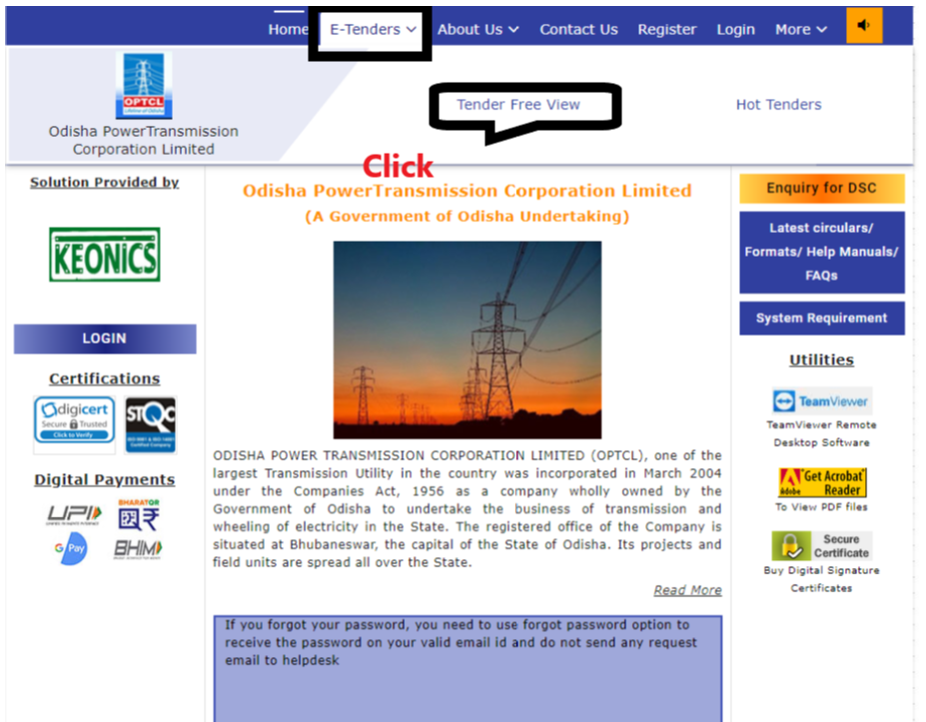
Step: 3
A new window will open.
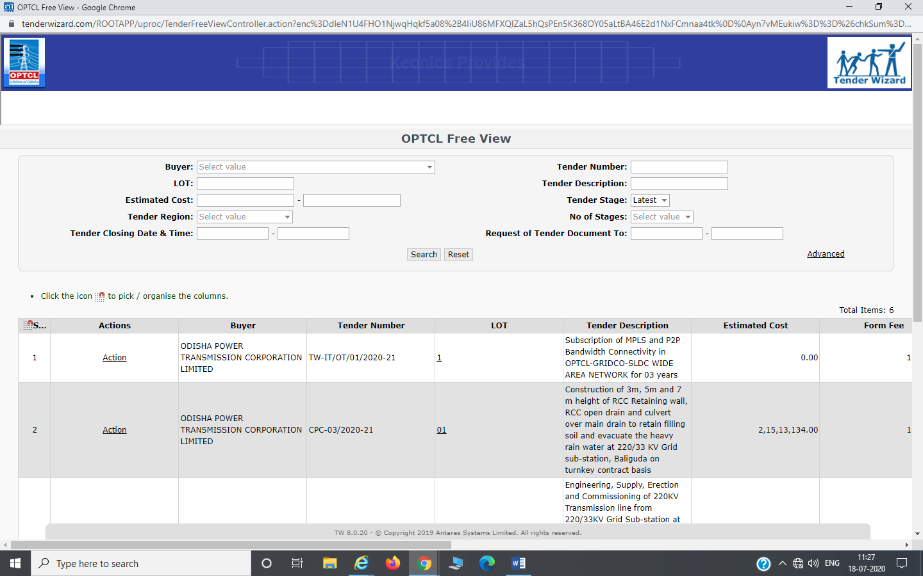

Step: 4
In the “Tender Description” text box provide the value as “DESIGN/ DEVELOP, SUPPLY, INSTALL, TESTING, COMMISSIONING AND MAINTENANCE OF ADMS FOR ODISHA POWER SYSTEM “and then click on “Search” button.

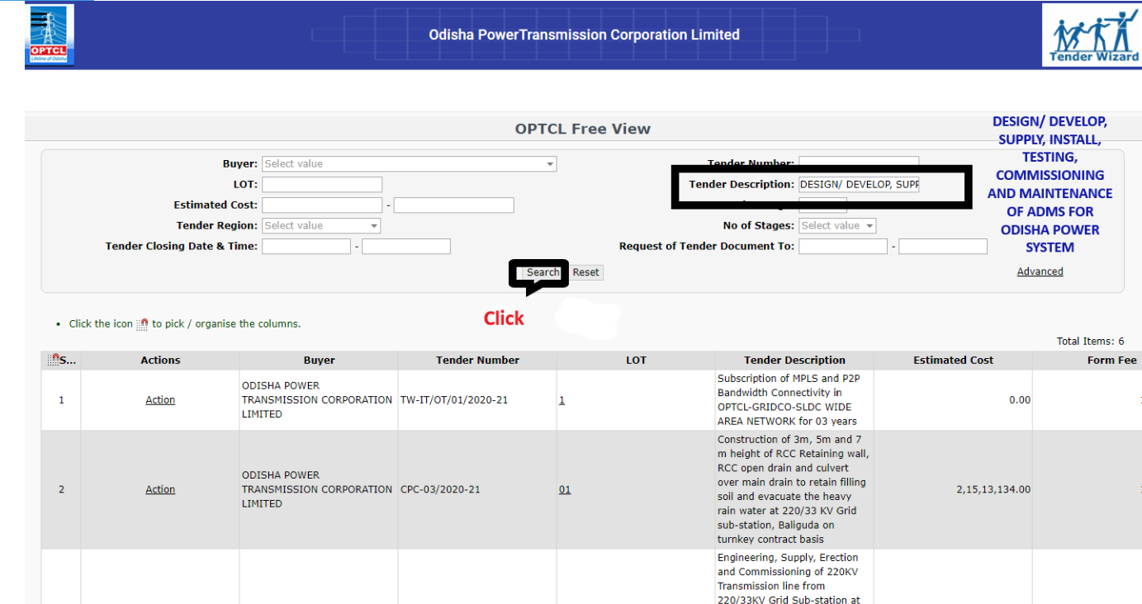

Step: 5
Click on the Action link.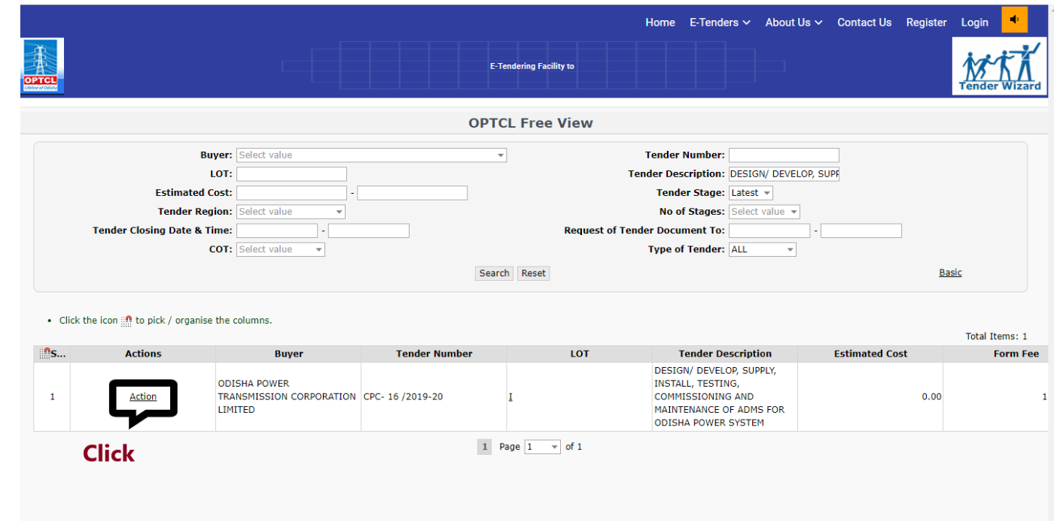

Step: 6
Then click on Show Form link.
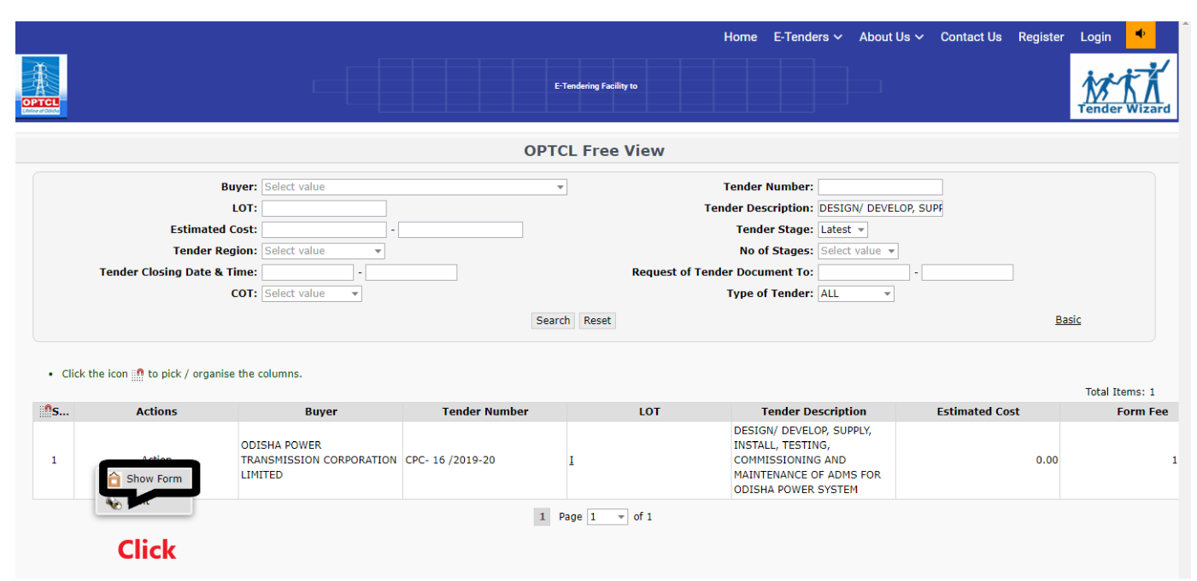

Step: 7
A popup dialog box will display and click on OK button in popup dialog box.

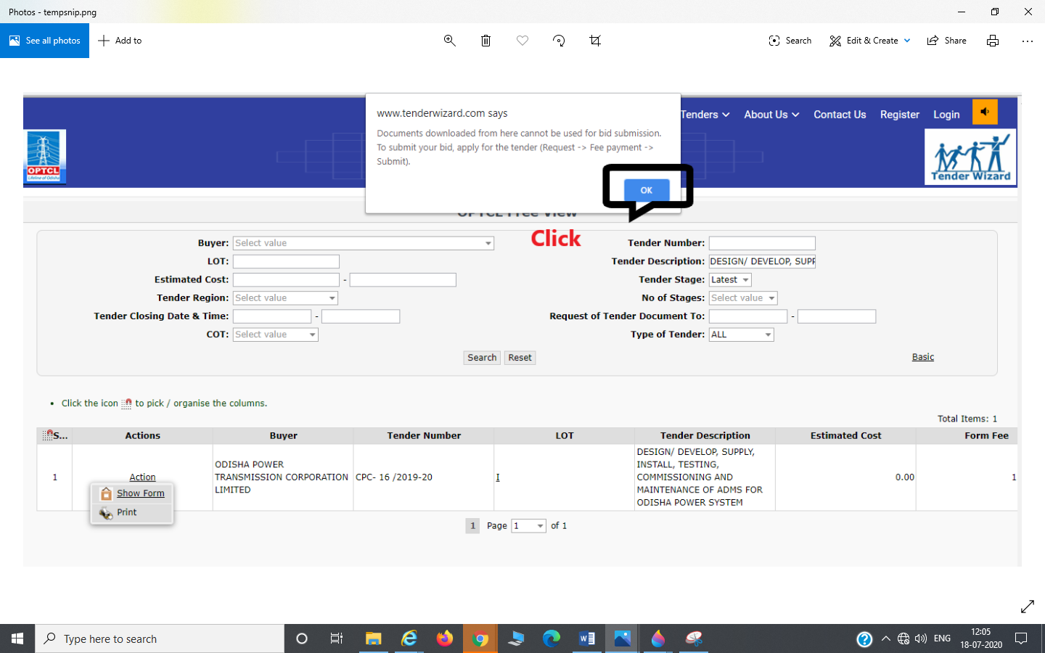

Step: 8
Then it will redirect to Tender documents and the Corrigendum/Addendum Details page.
